Data sheet and list of spare parts for Red Dragon® 3 flow-pump
For all Red Dragon® 3 Speedy 100 Watt / 12,0m3 pumps
FLOW Version
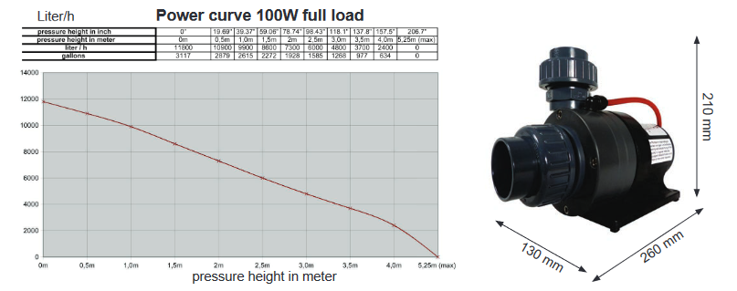

Data sheet and list of spare parts for Red Dragon® 3 flow-pump
For all Red Dragon® 3 Speedy 150 Watt / 18,0m3 pumps
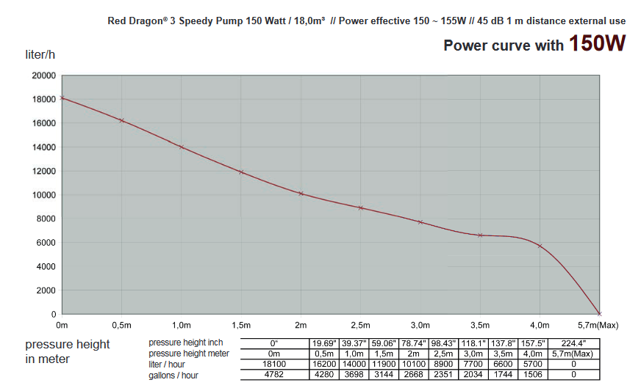

Data sheet and list of spare parts for Red Dragon® 3 flow-pump
For all Red Dragon® 3 Speedy 230 Watt / 24,0m3 pumps
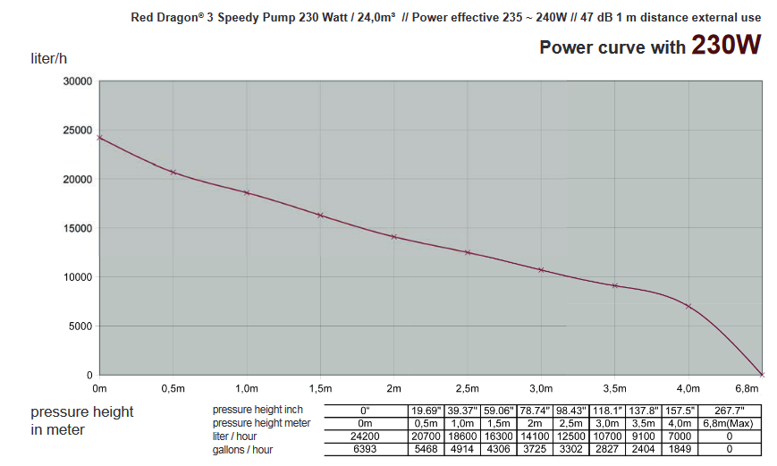
Data sheet and list of spare parts for Red Dragon® 3 flow-pump
For all Red Dragon® 3 Speedy 100 Watt / 9,0m3 pumps
HIGHPRESSURE Version
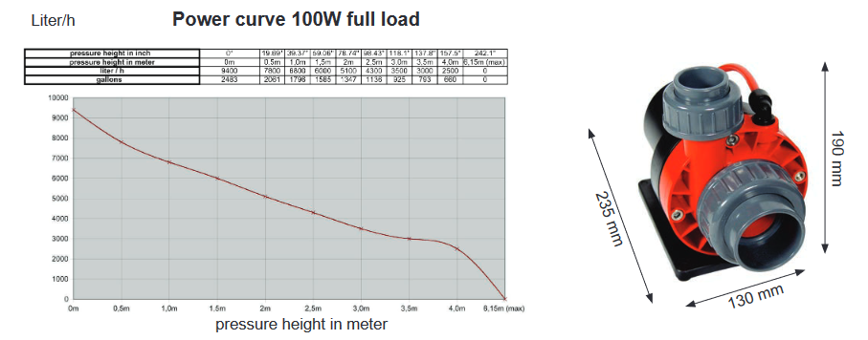

Data sheet and list of spare parts for Red Dragon® 3 pump
HIGH PRESSURE VERSION
For all Red Dragon® 3 Speedy 150 Watt / 17,0m3 pumps (High Pressure
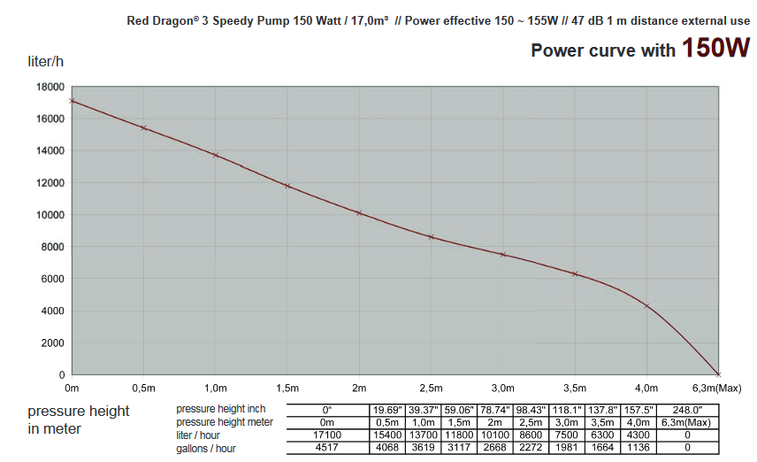

Data sheet and list of spare parts for Red Dragon® 3 pump
HIGH PRESSURE VERSION
For all Red Dragon® 3 Speedy 230 Watt / 19,0m3 pumps (High Pressure)
